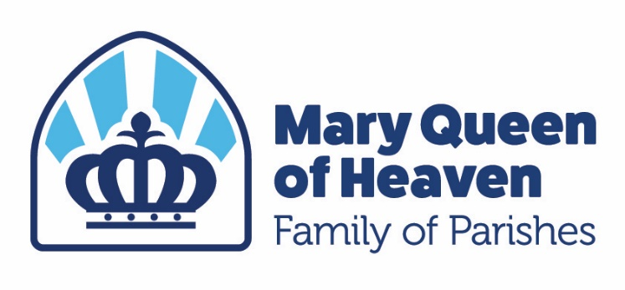
Catholic Summer Vacation Bible School
“Living in God’s Kingdom”
July 13 – 17, 2026
9:00 - noon
St. Ann Church and campus
2900 W. Galbraith Rd., Cincinnati, OH 45239
Email: pbevington@stjameswhiteoak.com
FINAL DATE FOR REGISTRATION – June 13, 2026
Father Home Phone Cell
^{(First Name)} ^{(Last Name)}
Mother Home Phone Cell
^{(First Name)} ^{(Last Name)}
Address City Zip
Family email address:
Kindergarten - 4th grade registrations Gender Date of birth Age Grade in the fall
#1_________________________________ F/M ____________ ____ ______
#2 ________________________________ F/M ____________ ____ ______
#3_________________________________ F/M ____________ ____ ______
#4_________________________________ F/M ____________ ____ ______

Indicate below if your child has a medical condition, learning disability, ADD, ADHD, allergies or special requirements of which our team should be aware of: __________________________________________________________________________________________________
In the event of an emergency, please contact (only if parents are unavailable):
Name: ____________________________________________ Phone: ________________________ Cell: ___________
Relationship: _____________________________________
Interested in helping with any of the programs: (circle one) YES NO
Parent/Guardian Signature: __________________________________________________________________________________________________
Program fees are due at the time of registration. Please use the Cheddar Up link to make payment on maryqueenofheaven.com. by June 13, 2026. The program fee is $35 per child. We have a scholarship program for those who need assistance. Please contact Pam Bevington in St. James Parish Office, 513-741-5300, extension 103.

